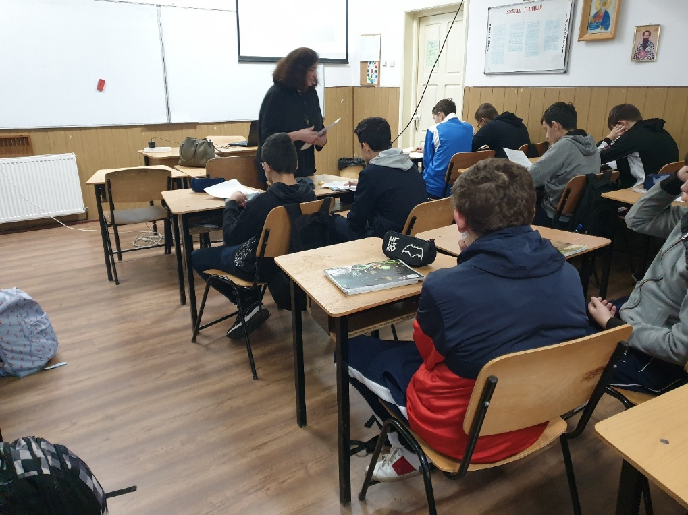
The activity was addressed to students aged 15-17 years. Students from three high school classes participated.
The time allocated to the activity / class was 2 hours / between October 4 and 10, 2019.

In the first hour the students watched and discussed with the teacher a film that was generically called: "50 things about the Moon you should know".
In the second hour the students completed a worksheet
(adapted after Cooperative Learning, Spencer Kagan, 1994).
In this fact sheet, 15 elements needed to survive on the Moon had to be prioritized.
After the individual prioritization, the team was made and compared with the one recommended by the specialists.
It was established at the end that obtained the score of: Survivor.
Discussions.

